## Indian Institute of Information Technology Surat



# Lab Report on

# Web Engineering (CS 603) Practical

**Submitted by**

### [RAHUL KUMAR SINGH] (UI21CS44)

**Course Faculty**

### Dr. Reema Patel

## Department of Computer Science and Engineering

## Indian Institute of Information Technology Surat

## Gujarat-394190, India

**Jan-2024**

## Lab No: 2

**Aim: HTML/CSS3/Bootstrap**

**Description:** Perform all the 12 Tasks:

1. Write HTML code to embed any video in a web document.

2. Write HTML code to embed any audio in a document.

3. Write HTML code to place the following web page into your web page. http://www.iiitsurat.ac.in/

4. Draw a square using HTML SVG, fill that square with yellow color and make a 5px blue stroke width.

5. Write HTML code to draw the given image using Canvas.

6. Write HTML code to draw a rectangle using Canvas and fill color in gradient from red to pink from start to end.

7. Creating HTML code using CSS3 selectors

8. Creating HTML code using CSS3 backgrounds and transparency

9. Creating HTML code Using CSS3 fonts and text effects

10. Creating HTML code 2D and 3D transformations, transitions, animations and resize property with CSS3

11. Build a Good Vibes Form Using HTML, CSS3 and Bootstrap

12. Build a Product Landing Page Using HTML5, CSS3 and Bootstrap

## Source Code:

**Task 1:**

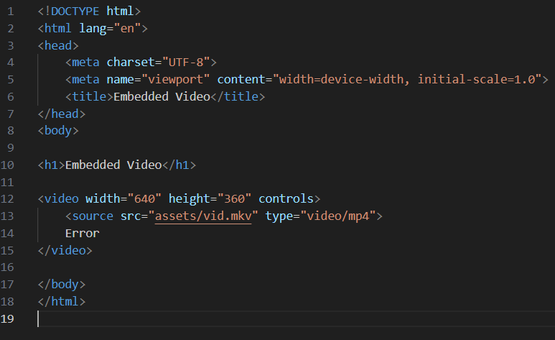

**Task 2:**

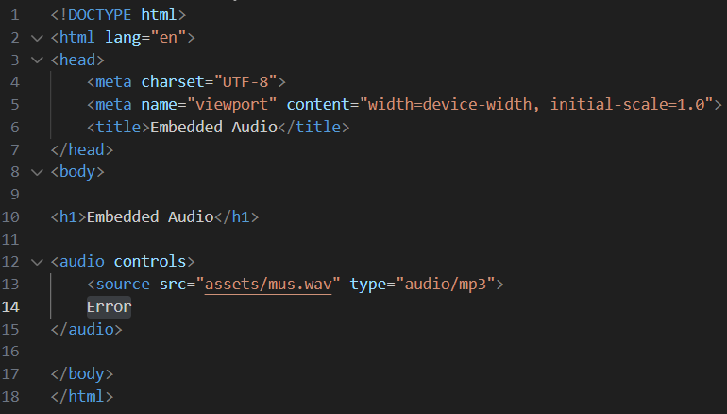

**Task 3:**

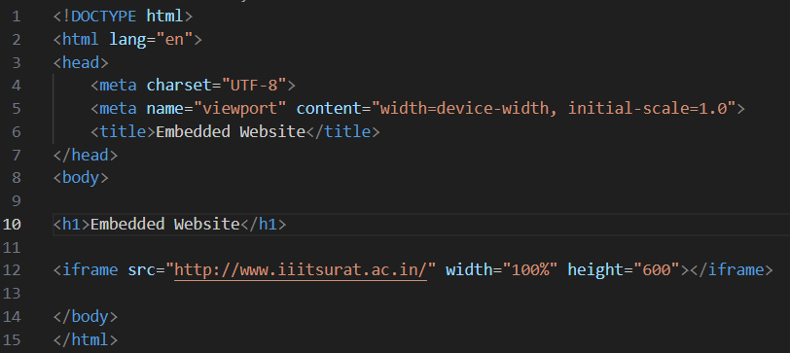

**Task 4:**

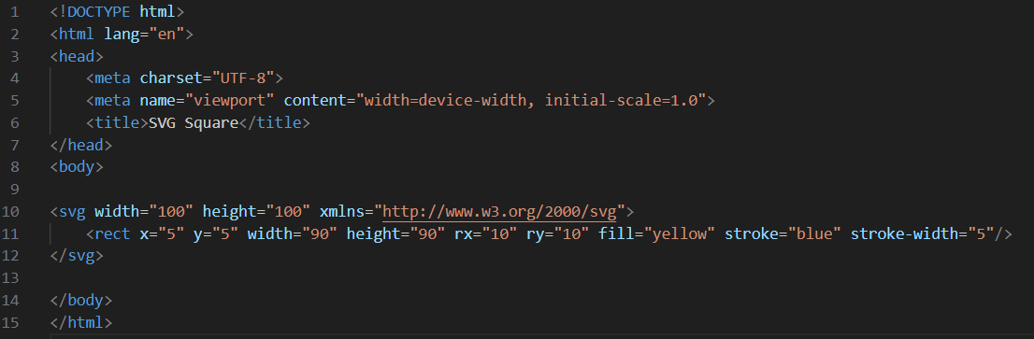

**Task 5:**

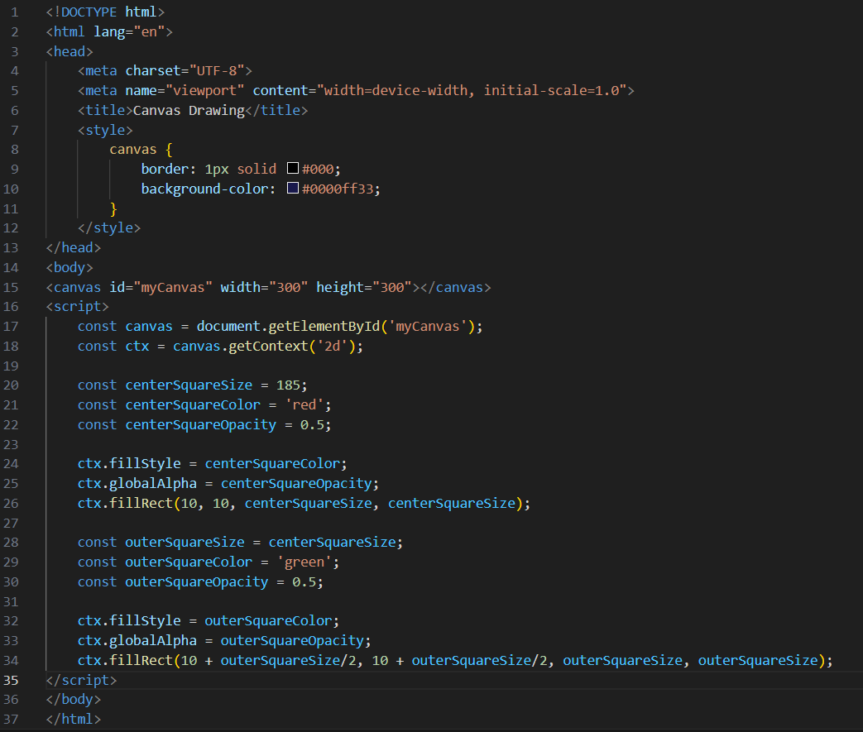

**Task 6:**

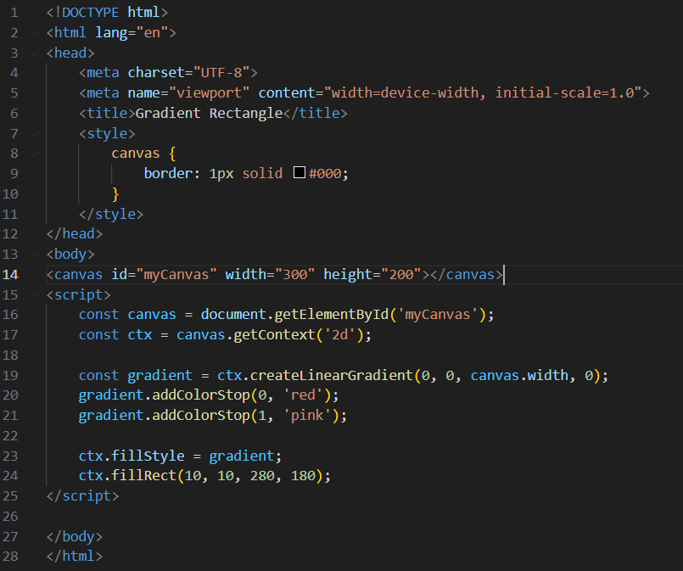

**Task 7:**

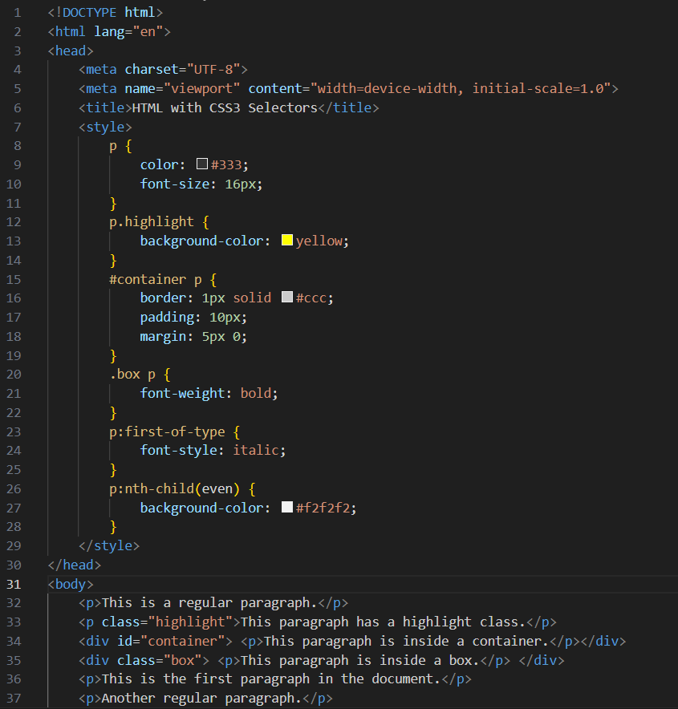

**Task 8:**

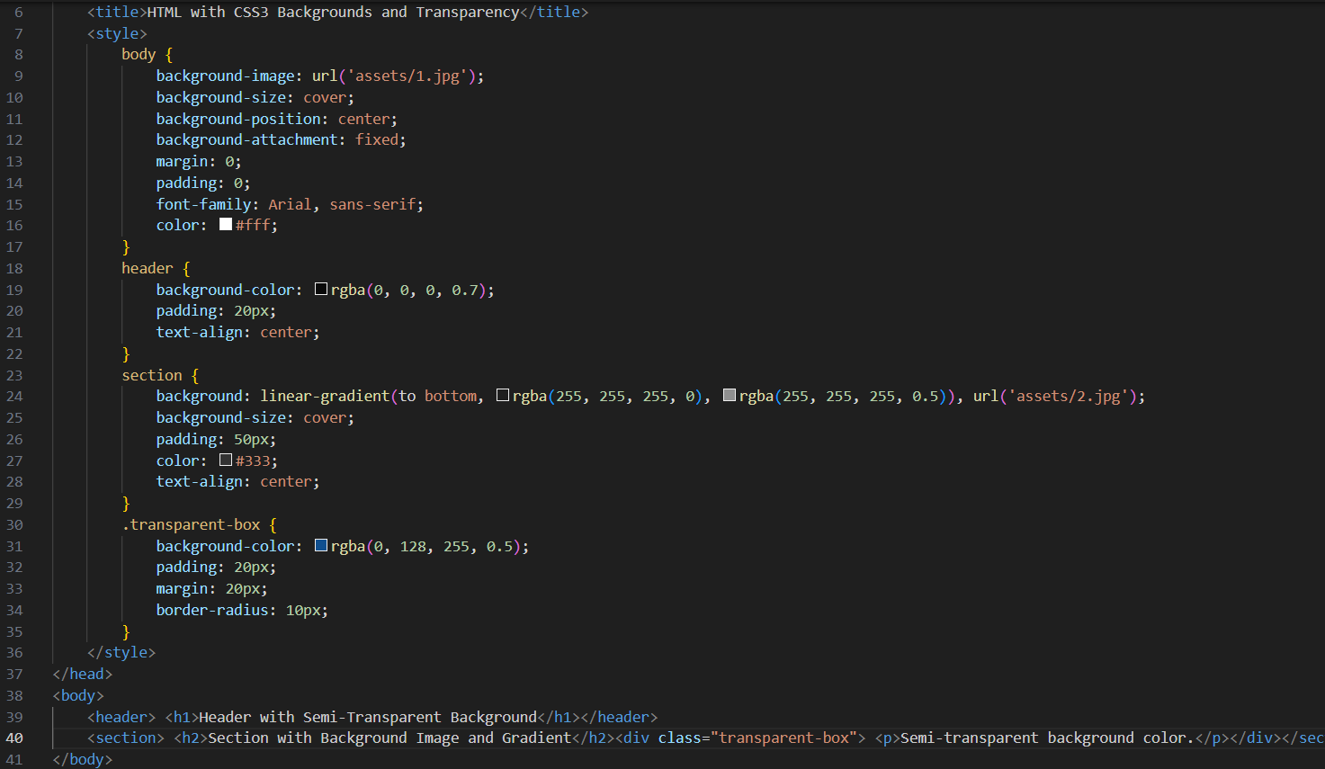

**Task 9:**

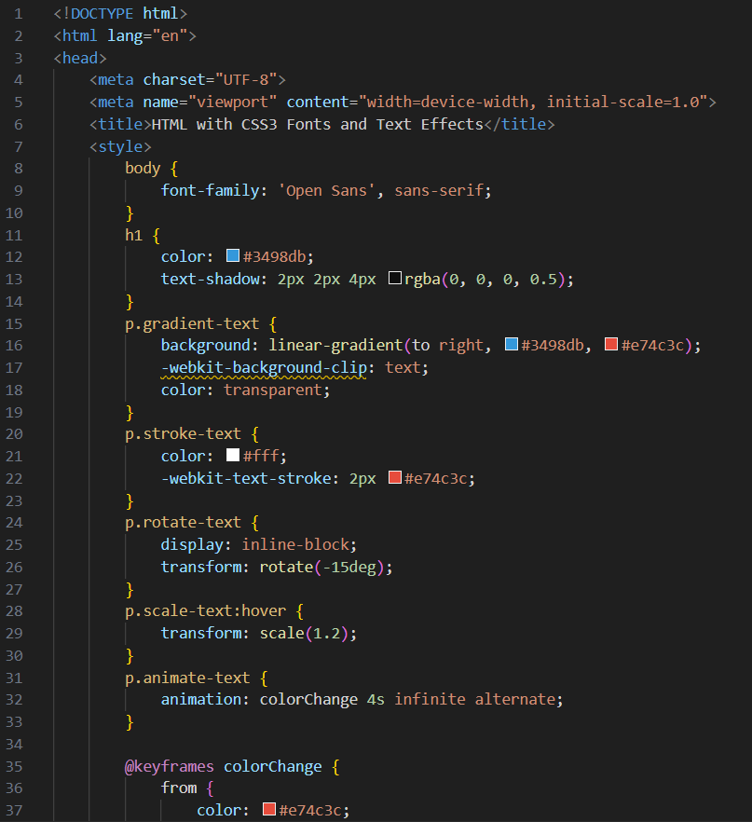

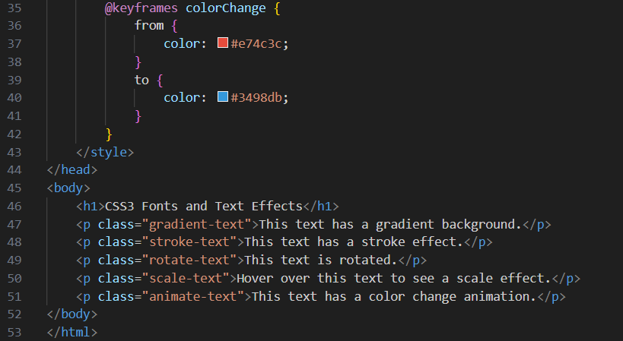

**Task 10:**

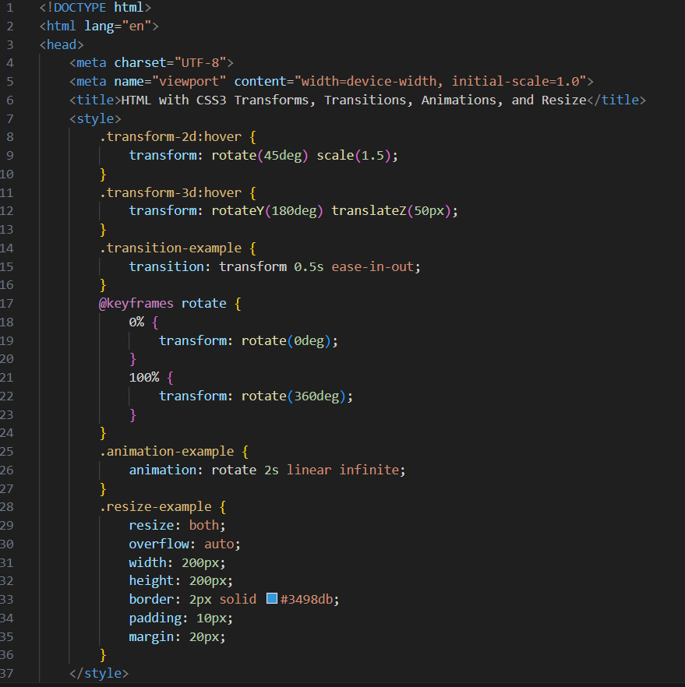

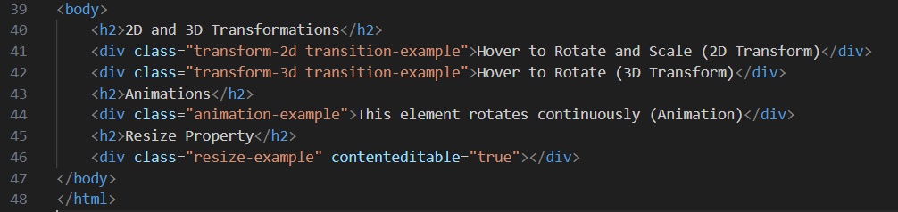

**Task 11:**

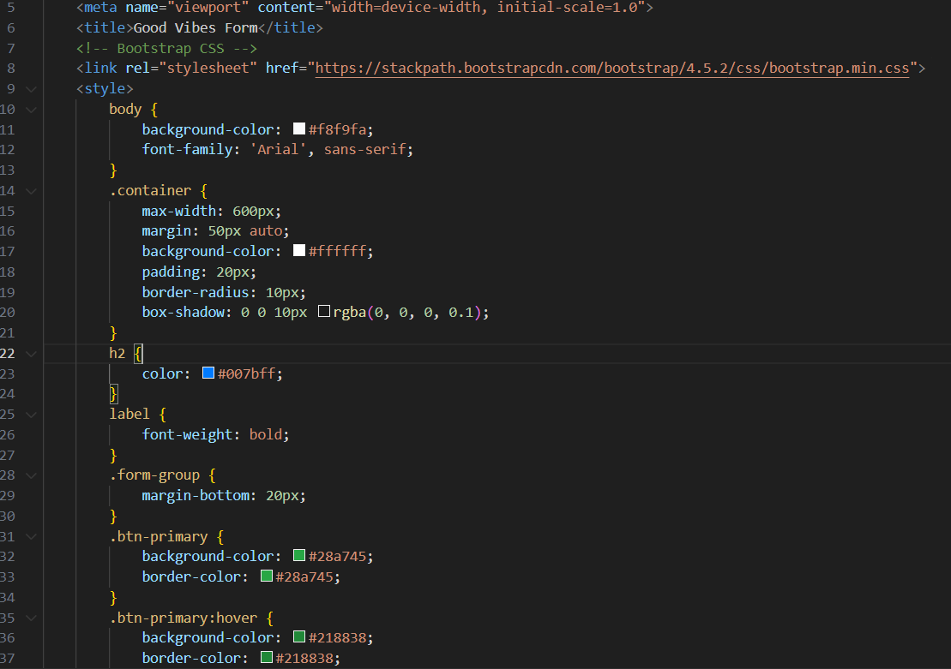

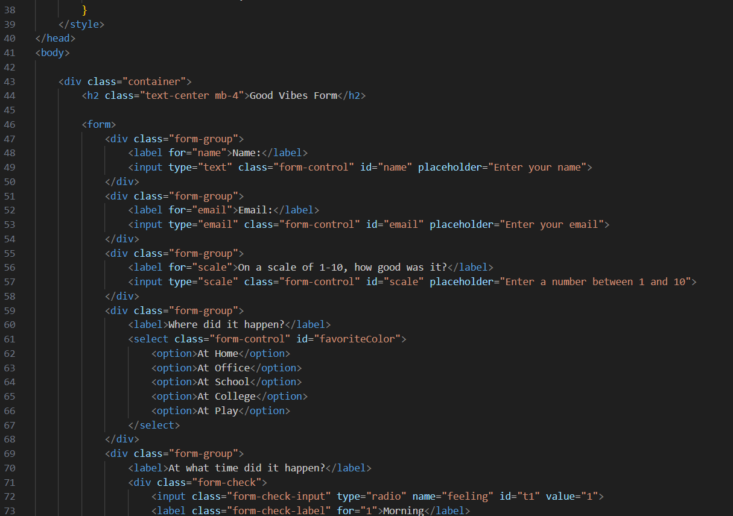

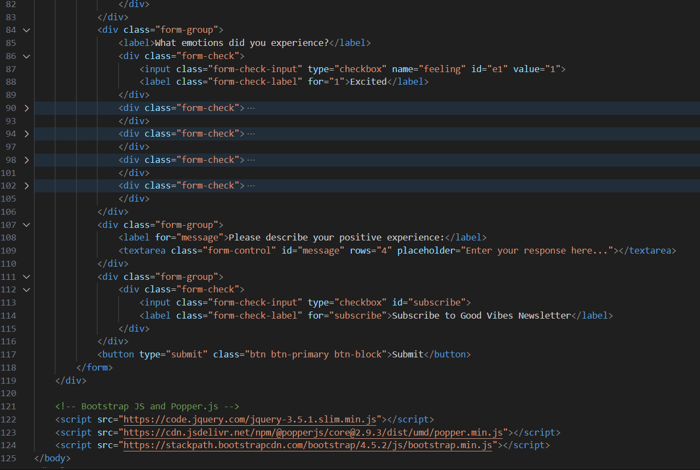

**Task 12:**

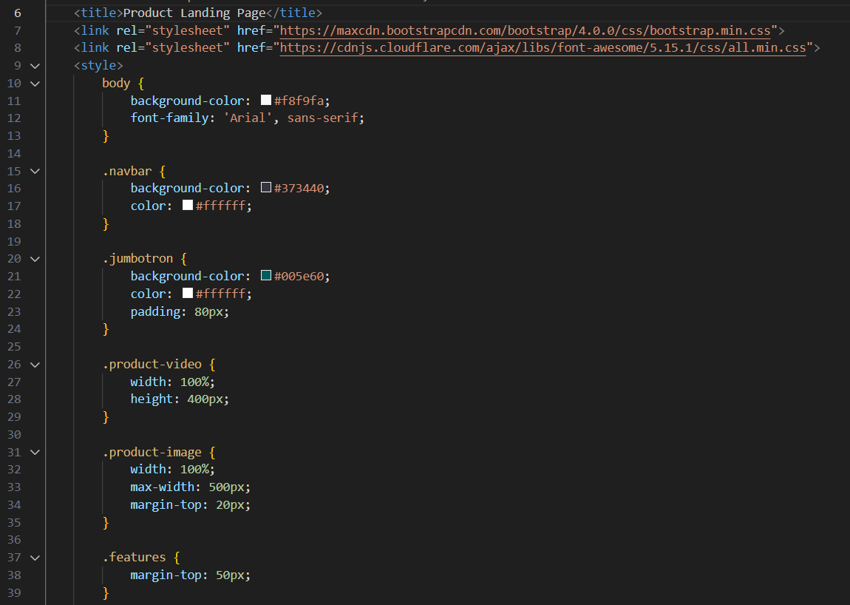

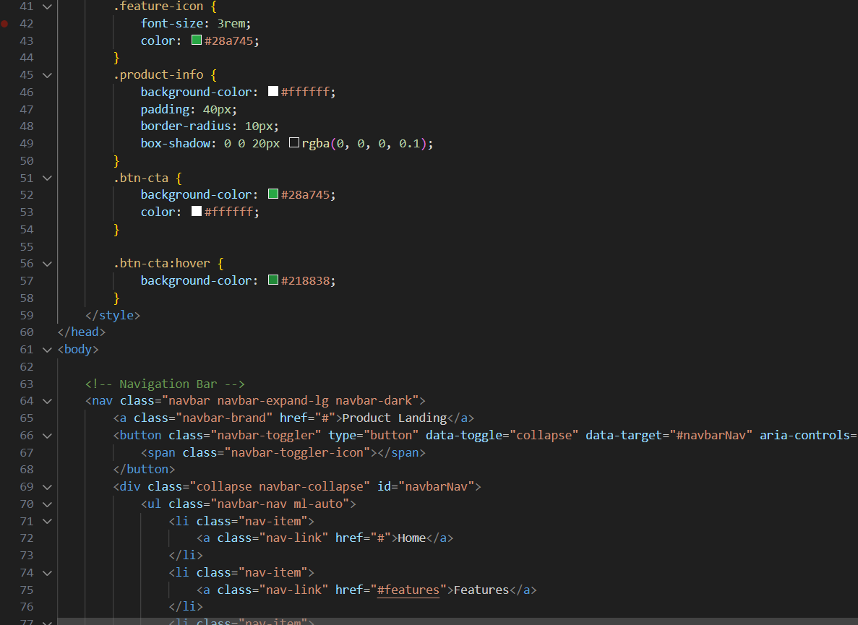

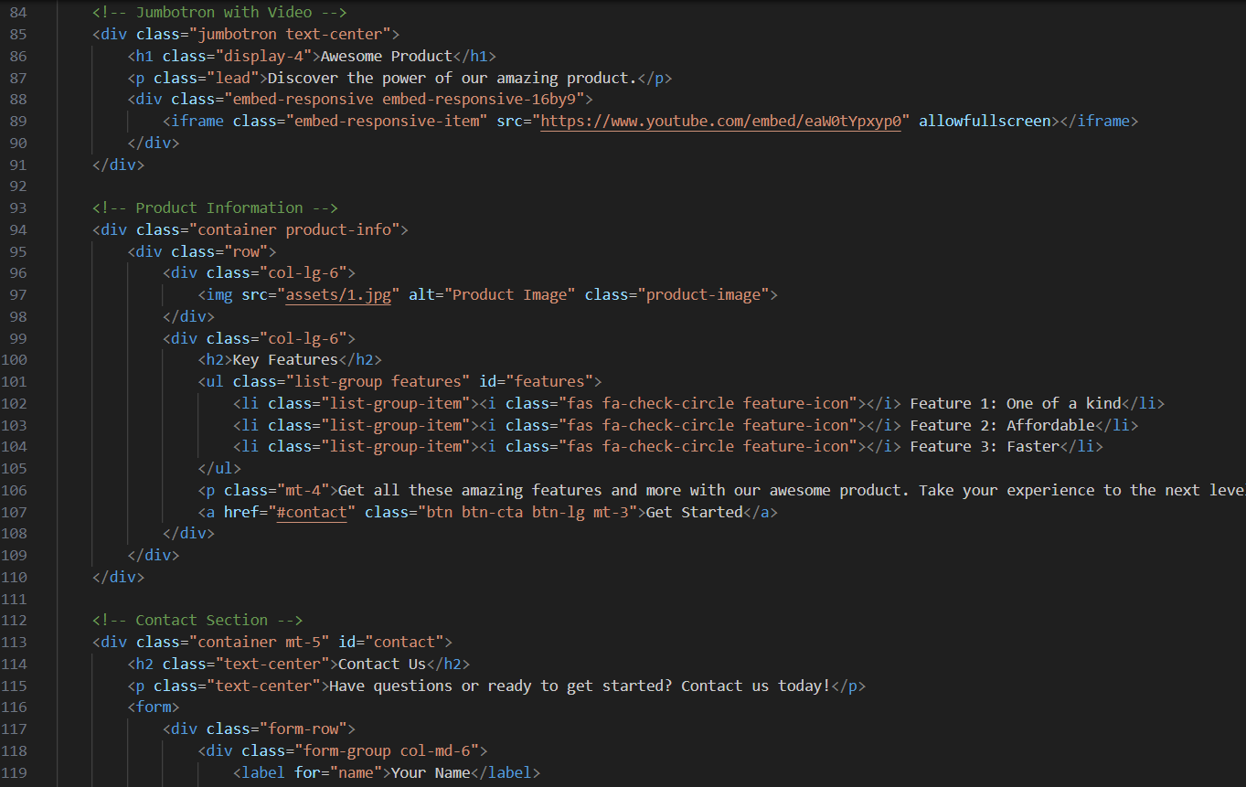

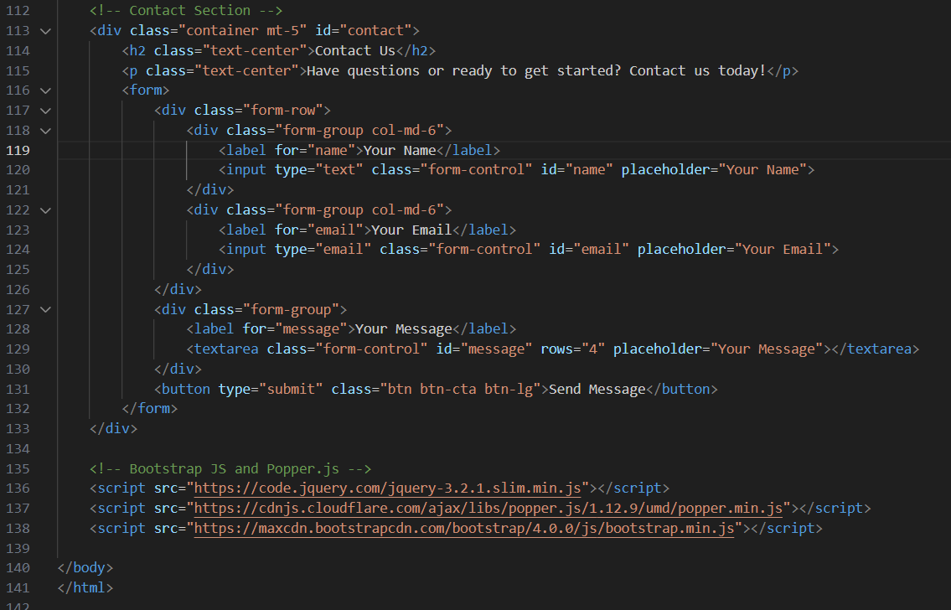

## Output:

**Task 1:**

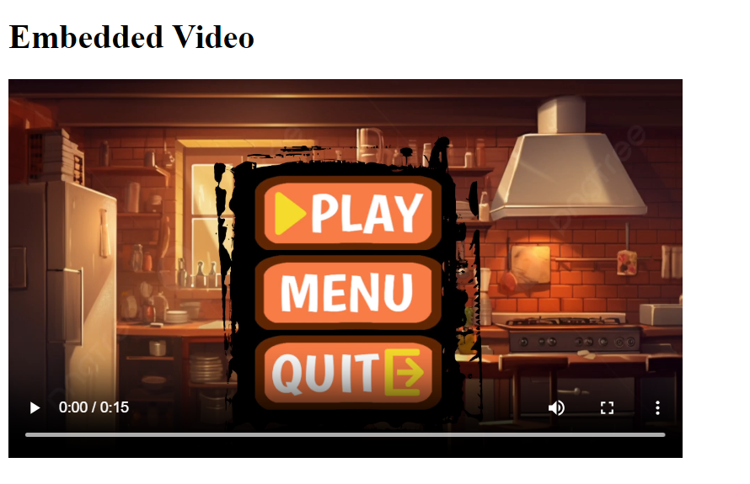

**Task 2:**

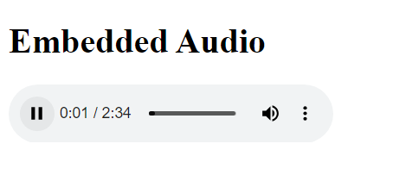

**Task 3:**

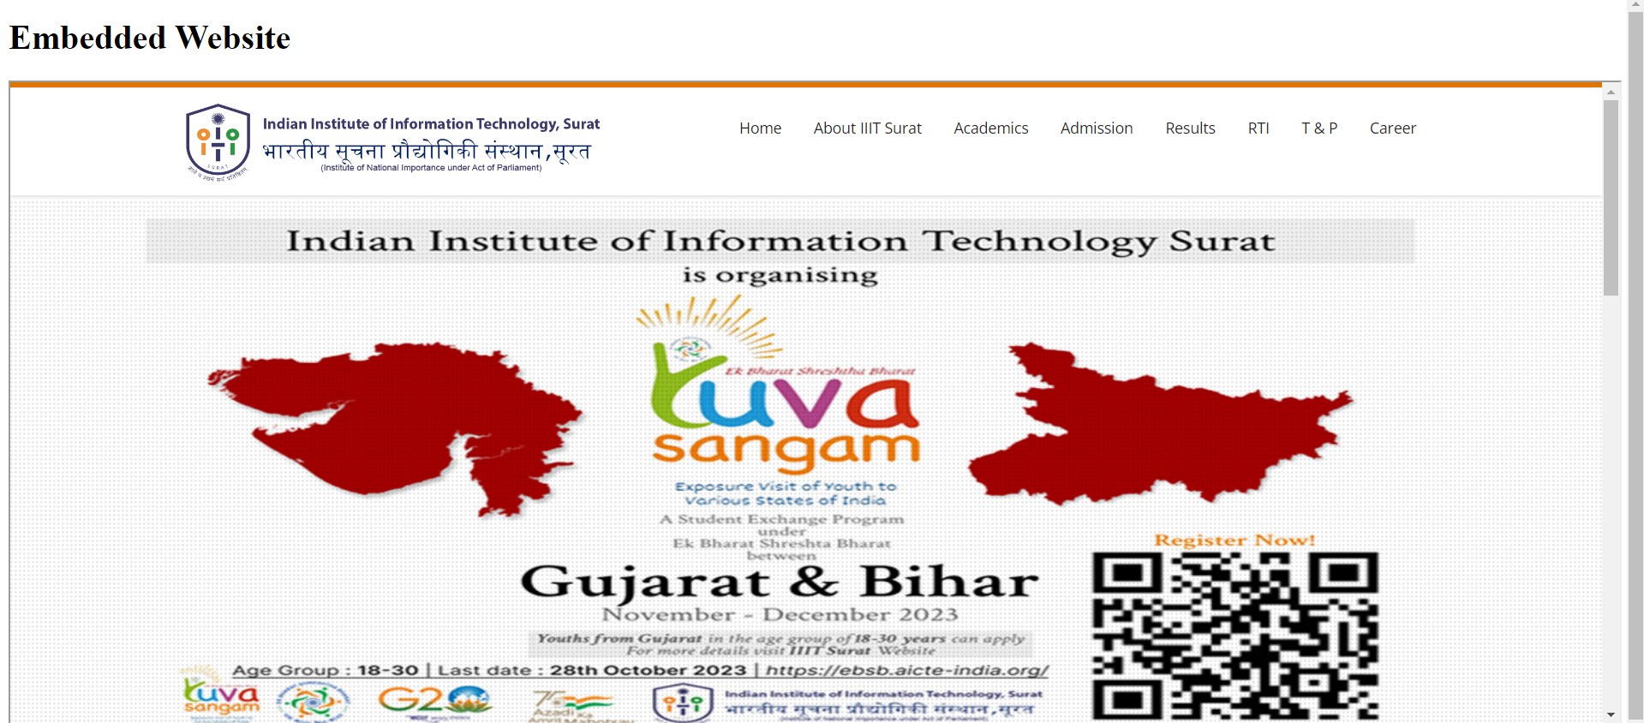

**Task 4:**

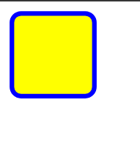

**Task 5:**

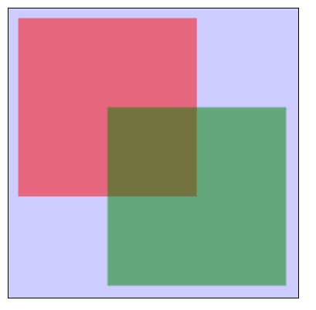

**Task 6:**

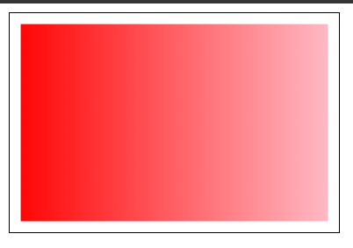

**Task 7:**

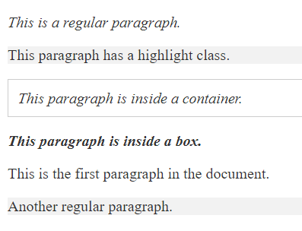

**Task 8:**

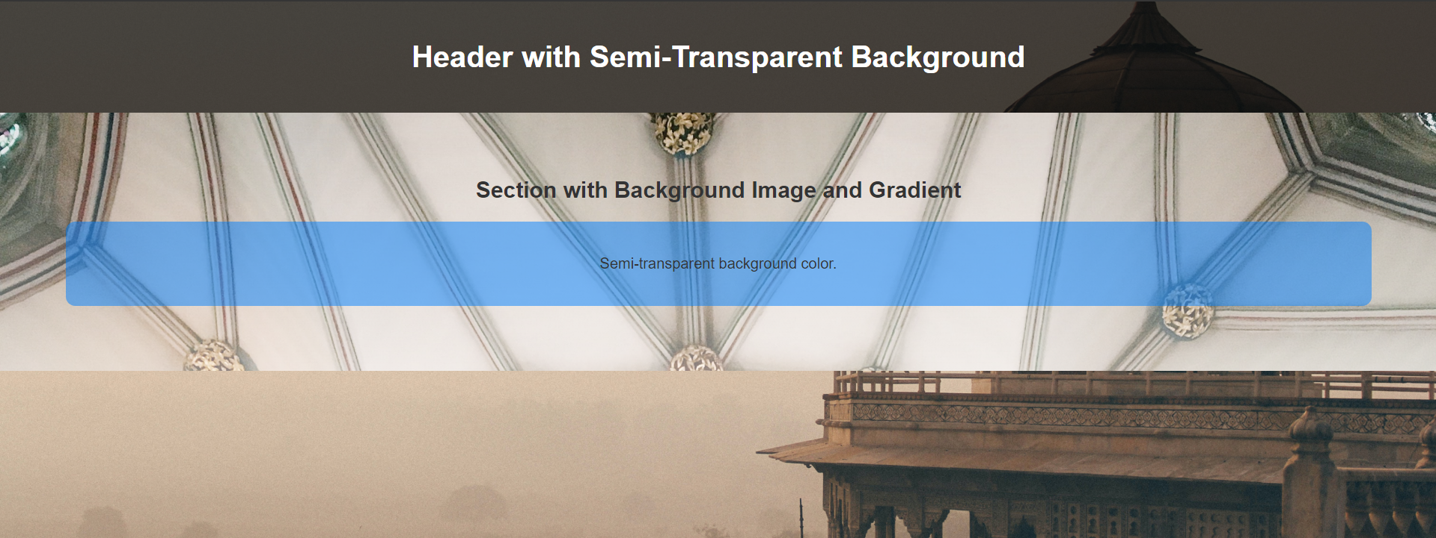

**Task 9:**

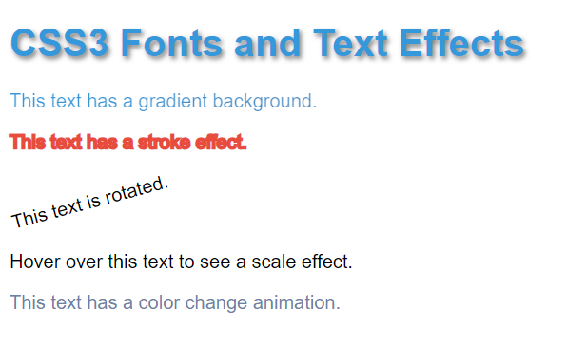

**Task 10:**

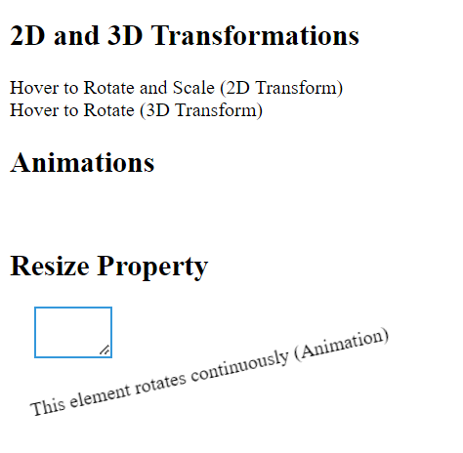

**Task 11:**

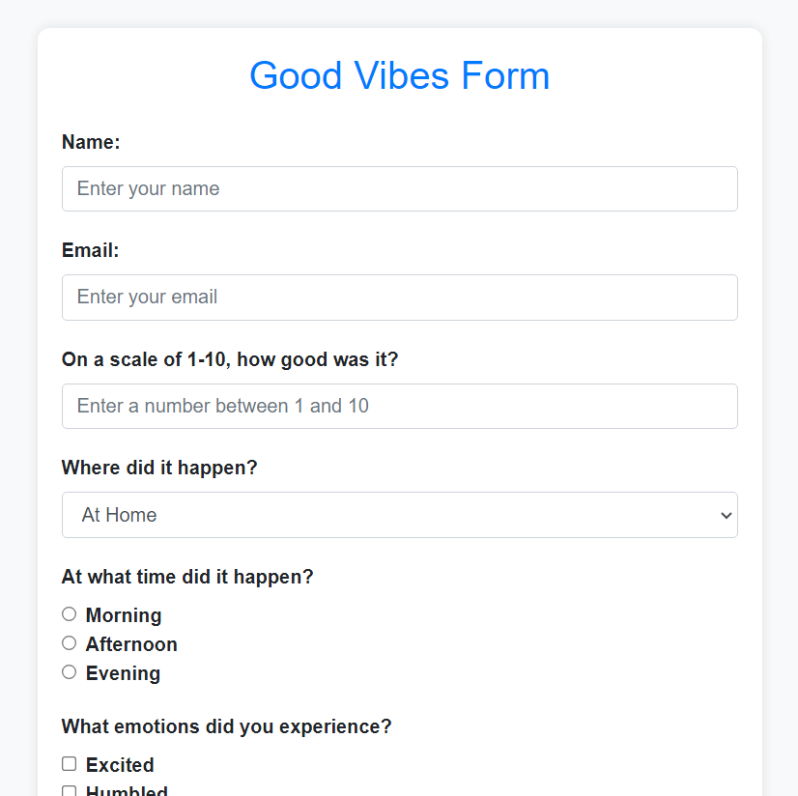

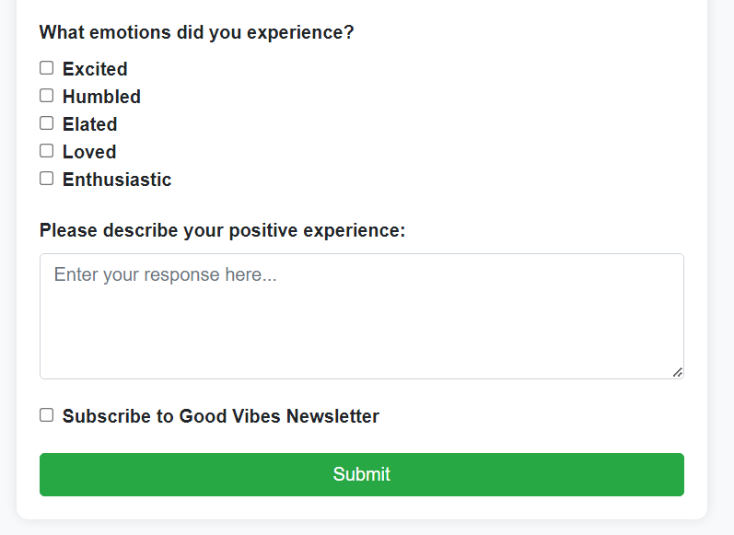

**Task 12:**

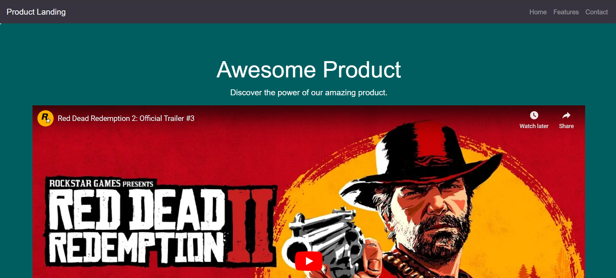

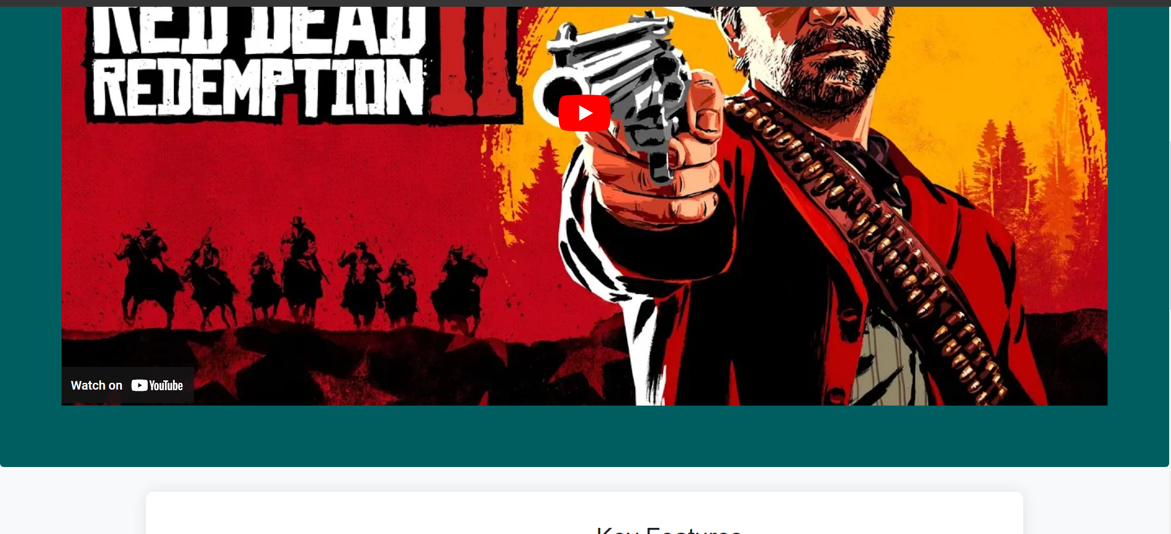

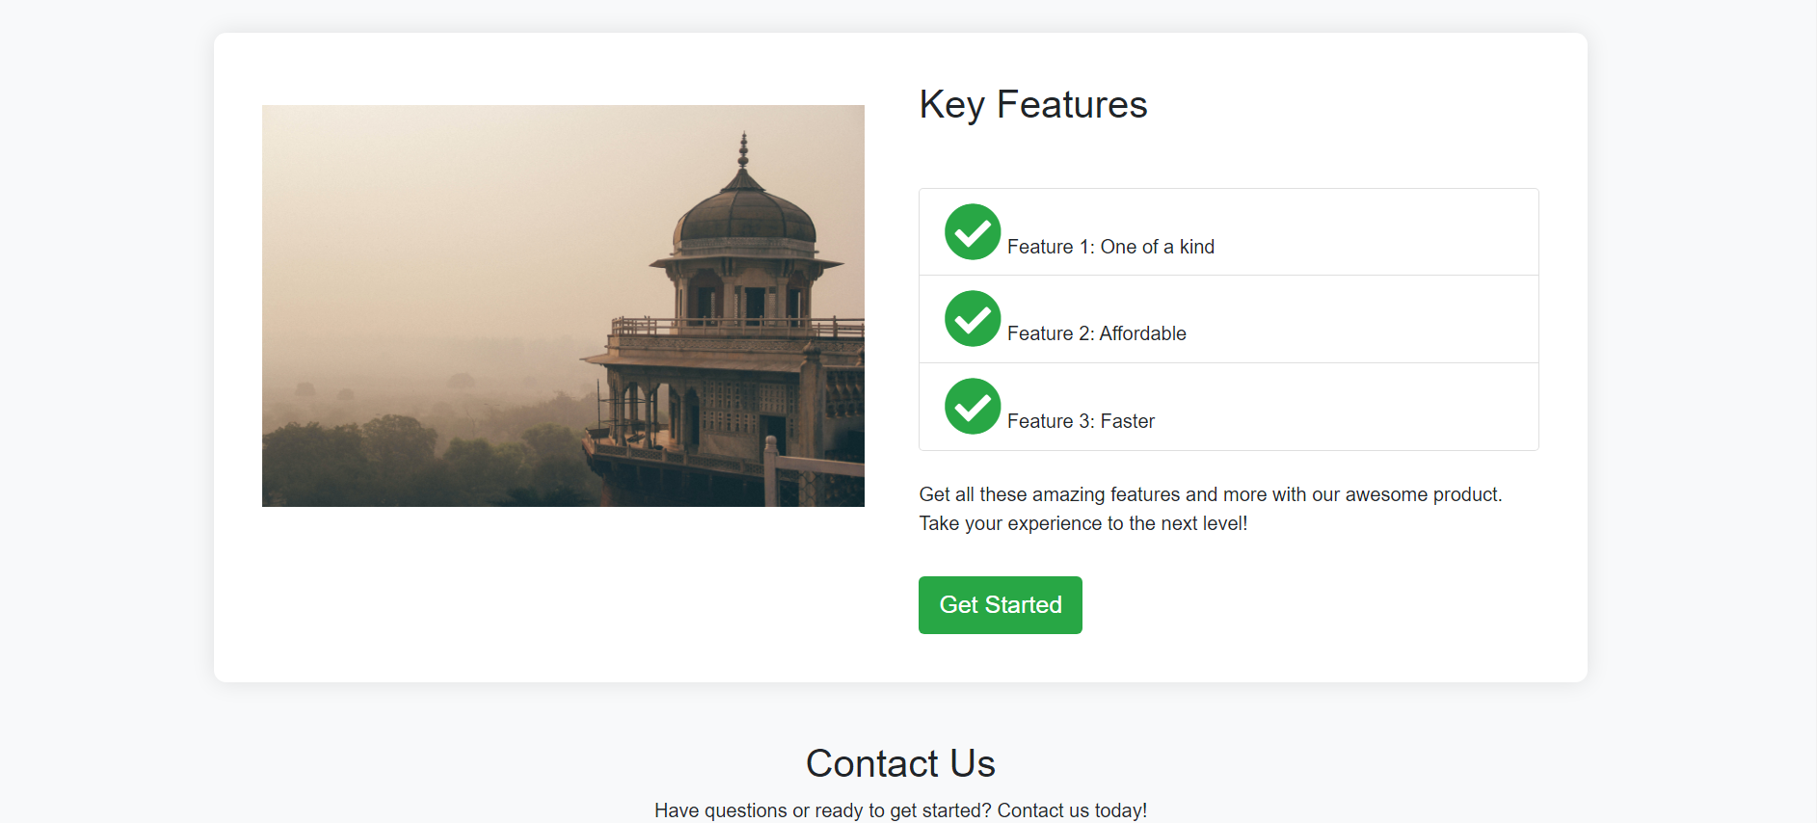

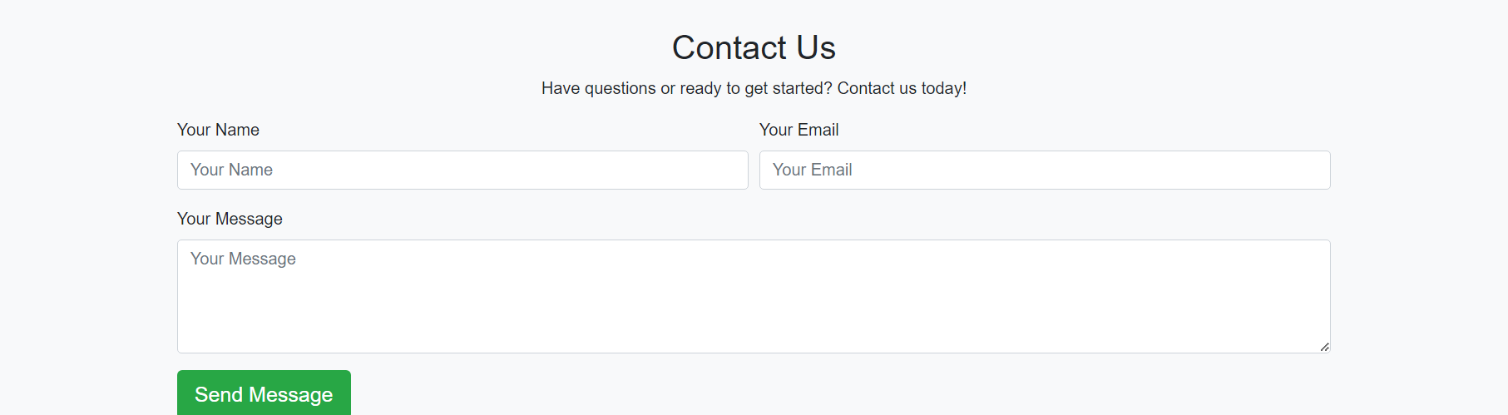

## Conclusion:

* Proper structure and semantics were maintained for better accessibility and SEO.
* The use of external libraries and frameworks, such as Bootstrap and Font Awesome, allowed for efficient styling and consistent design across various components.
* Techniques like transformations, transitions, and animations were employed to enhance user experience.